Julianne Delia

Taming Big Data

2/19/2019

Sentiment Analysis Homework: Parkland Tweets

After carefully sifting through the tweets about the anniversary of the Parkland school shooting, I can clearly see why fear, a negative sentiment, would be the strongest emotion. A lot of the tweets and re-tweets discuss the “heinous act” and “gun safety”, which are two subjects that could and would spark a negative emotion.

I think fear is dominating the Twitter conversation because a lot of people are afraid of things related to this shooting. People are afraid of sending children to school with the possibility of being killed by an active shooter. People are afraid of how violent the country is becoming and how easily people have access to violent weapons. Simply put, people are afraid.

Some of the words that stood out to me in a lot of the tweets were “massacre”, “shooting”, “heinous”, “gun violence”, “lives lost”, “pain”, “death”, “deadliest”, and “dangerous.” All of these words are words that spark fear and terror among most (if not all) human beings. One tweet that I saw a lot, due to the fact that it was re-tweeted, was “One year ago the Parkland community lost lives in a heinous act of gun violence.” A lot of people that re-tweeted this tweet were parents. They had the word “mom”, “dad”, or “parent” in their user bio. This does not surprise me because parents are probably the people feeling the most fear. They are afraid of doing the one thing every parent dreads: burying their child. Parents want to know they are sending their children to a safe place when they send them to school, and the fear of the unknown is most likely the strongest kind of fear. I’m sure the parents of the victims did not know their children would be attending an unsafe school that day.

The most interesting part of this data was the amount of gun supporters commenting on this specific school shooting. There were several twitter bios that mentioned “MAGA” (Trump’s mantra) and “NRA supporter.” These tweets fell under the fear category because they expressed concern about their second amendment rights being taken away due to the amount of people demanding stricter gun control laws. One tweet that *really* stood out was: “If a criminal ever uses a gun to kill me DO NOT USE MY DEATH as a pretext to strip rights away from other law abiding citizens Sadly this is exactly how the anti second amendment people are USING the people that died at Parkland MSDStrong.” This user’s bio said “Motorcycles, Deep powder, Beer, and Guns. Lean right. Clutch fan. Jumbo lump only. #NRA Life member. #MAGA” This is an example of someone who was fearful about their second amendment rights being restricted. I did not expect to see someone expressing fear in this sense amongst the Parkland conversation. Nevertheless, it is still an example of someone expressing fear in the Parkland Twitter conversation.

Overall, I was not surprised by the fact that fear was the strongest emotion while discussing Parkland on the anniversary of the shooting. I was also not surprised by the fact that most of the users expressing fear were parents. The only thing that did catch me off guard was the amount of people pushing their conservative agenda during a time that most people used to mourn the lives lost.

**Bar plot:**

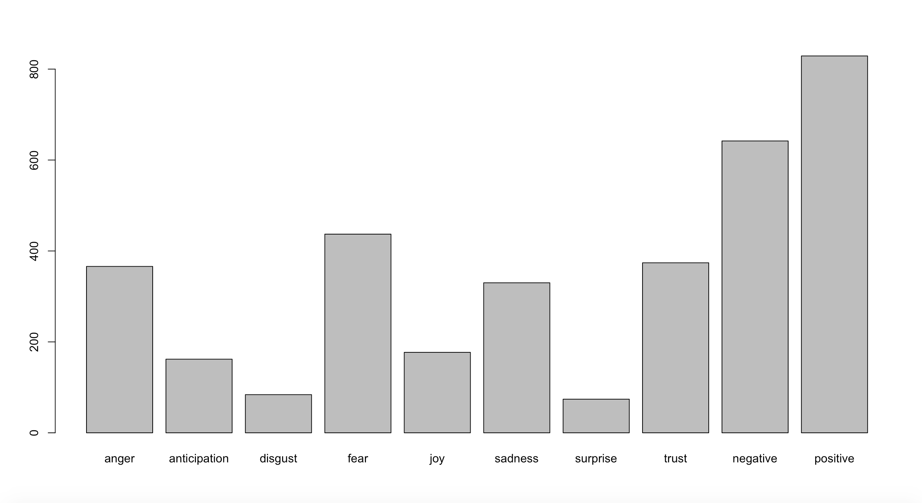

From this bar plot, the strongest emotion is “fear.” Fear is a negative emotion and has column total of 437.